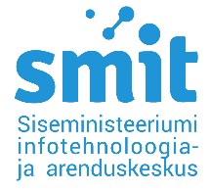

Mr Juhan Lepassaar  ENISA | Our ref no 2-5/19, 15.11.2024

Letter of Support

Dear Mr Juhan Lepassaar

The IT and Development Centre of the Estonian Ministry of the Interior (SMIT) welcomes and supports the establishment of the AHWG on EUDI Wallets. eIDAS2 and development of EUDI wallets are both crucial for the continued development of Estonian digital society and we plan to take full advantage of the harmonised certification scheme once it is finalised.

SMIT has been fortunate to work with long-term partners in Estonia for their expertise on the topics of certification. For that reason, we support the candidacy of Mr. Aivo Kalu, Lead Security Engineer from Cybernetica AS, as a member of the AHWG.

Yours sincerely,

Kaija Kirch
Head of Identity Services Department

Kaija Kirch, kaija.kirch@smit.ee

